Computer Networks

Lab Manual 3

**PART 1:**

**1- List up to 4 different protocols that appear in the protocol column in the**

**unfiltered packet-listing window.**

1. SNMP
2. DNS
3. TCP
4. HTTP

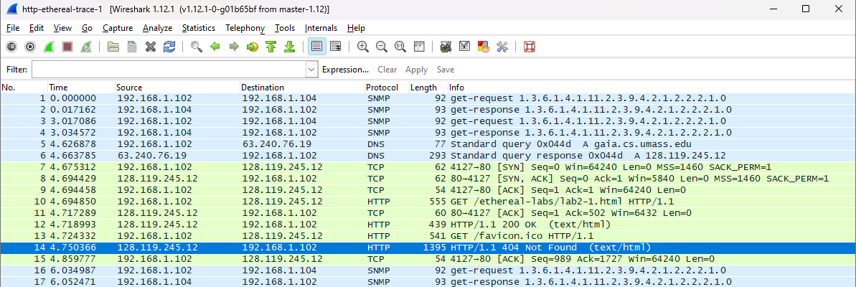

**2- How long did it take from when the HTTP GET message was sent until the HTTP OK reply was received?**

4.718993 - 4.694850 = 0.024143



**3- Was the second Get Request successful? How can you tell it from the corresponding response packet?**

No, the response was not successful as can be seen from the response status code 404 which means the page was not found.

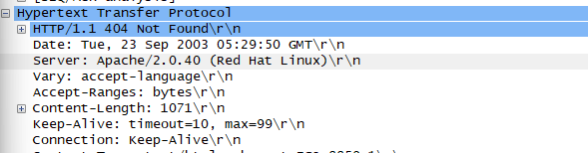

**4. Is your browser running HTTP version 1.0 or 1.1? What version of HTTP is the server running?**

Both the browser and the server are running HTTP 1.1.

**5. What languages (if any) does your browser indicate that it can accept from the server?**

En-us, en; q=0.50

**6. What is the IP address of the gaia.cs.umass.edu server and your computer?**

Server: 128.119.245.12

Computer: 192.168.1.102



**7. What is the MAC address of the server and your computer?**

Server: Address: 00:06:25:da:af:73

Computer: 00:08:74:4f:36:23

**8. What is sending and receiving Port Number? What does Port No. 80 represent?**

Sending: 4127

Receiving: 80

The post no. 80 is the default post number for web application utilizing the HTTP

Protocol.

**9. What is the status code returned from the server to your browser?**

First request: 200 (success)

Second request: 404 (page not found on the server)

**10. When was the HTML file, that you are retrieving, last modified at the server?**

First: Tue, 23 Sep 2003 05:29:00 GMT

Second: Not found so last modified not present

**11. How many bytes of total packet content are being returned to your browser?**

First: 439 BYTES

Second: 1395 BYTES



**PART 2:**

**1. Inspect the contents of the first HTTP GET request from your browser to the server. Do you see an “IF-MODIFIED-SINCE” line in the HTTP GET?**

“if-Modified-Since” is not present in the first GET request.

**2. Inspect the contents of the server response. Did the server explicitly return the contents of the file? How can you tell from the Packet Bytes Window?**

First: Content has been returned as the HTML tags can be observed.

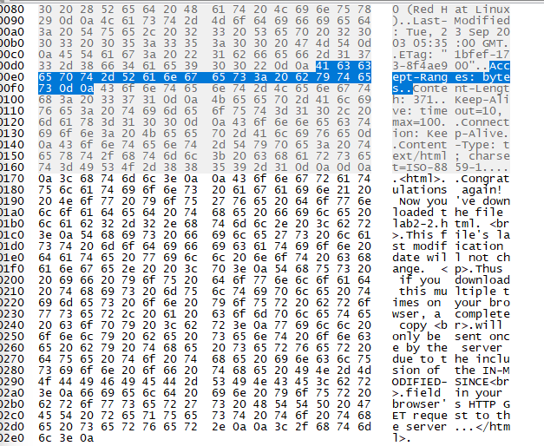

Second: No content has been returned by the server.

**3. Now inspect the contents of the second HTTP GET request from your browser to the server. Do you see an “IF-MODIFIED-SINCE:” line in the HTTP GET? If so, what information follows the “IF-MODIFIED-SINCE:” header? What is meant by this information?**

This informs that the data from the server should only be retrieved if it has been modified after the date in front of the header i.e., Tue, 23 Sep 2003 05:35:00 GMT.

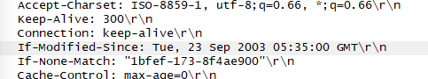

**4. What is the HTTP status code and phrase returned from the server in response to this second HTTP GET? Did the server explicitly return the contents of the file? Explain your answer**

304 (not modified) returned. The server did not return the file as it has not been updated since the date used in the condition. A cached copy may be present that may be loaded by the browser.

**5. How many HTTP GET request messages did your browser send?**

1



**6. Which packet number in the trace contains the GET message for The Bill**

**of Rights?**

Packet 9

**7. Which packet number in the trace contains the status code and phrase**

**associated with the response to the HTTP GET request?**

Packet 14

**8. What is the status code and phrase in the response?**

200 (OK)

**9. How many data-containing TCP segments were needed to carry the single**

**HTTP response and the text of the Bill of Rights? What are the numbers of those packets?**

4 packets. Packet no. 9-13

**What is the length of the text for The Bill of Rights in bytes? How do you justify this length of text when your Response Packet Size is only 490 bytes? Give complete explanation how the length of text in various packets add up to a total of 4500 Bytes.**

3 packets made by the TCP protocol for long HTML response: 3 x 1460 bytes

Size of the response + content packet: 436(total packet size) – 316[(13c)] (header size)

Total = 4500 bytes